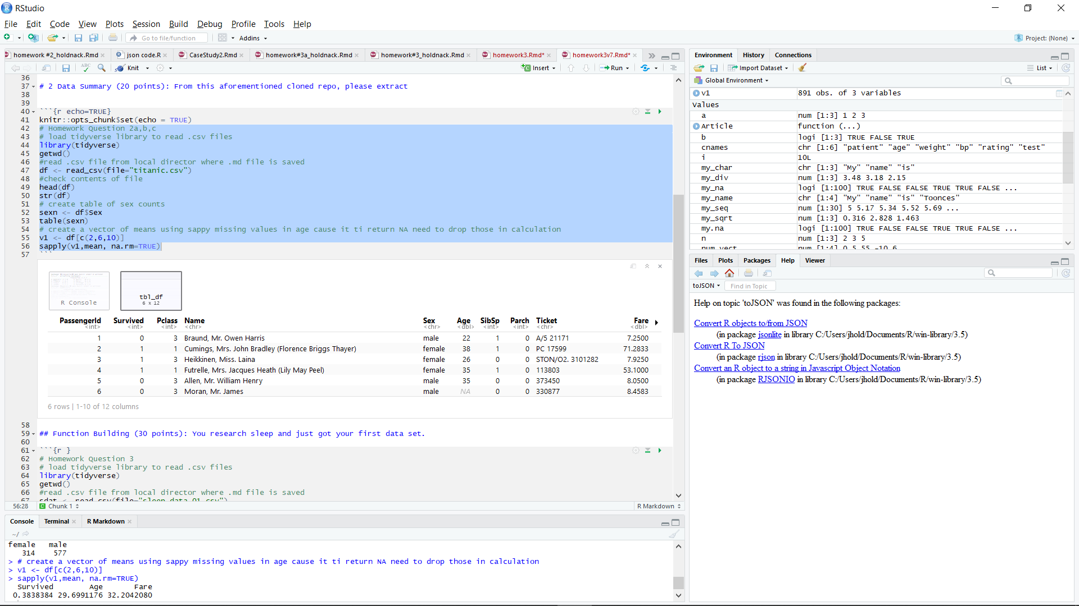

Section 1: note no errors, at the bottom the code returns correct values for survived. Age, fare

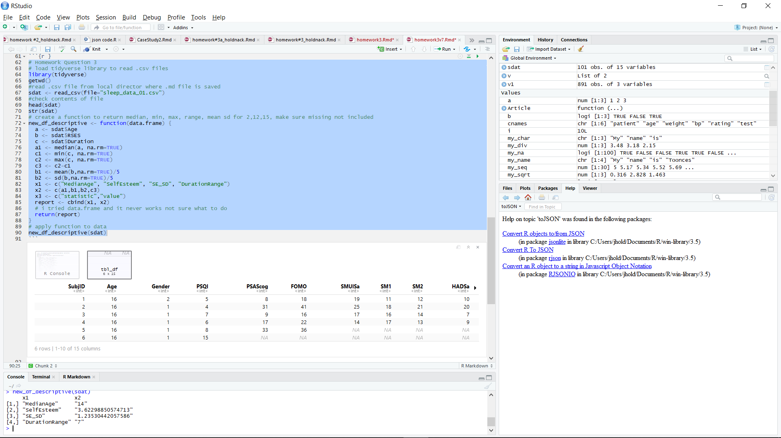

Section 2: code works – file loads correctly and I get values as expected for the 4 variables requested

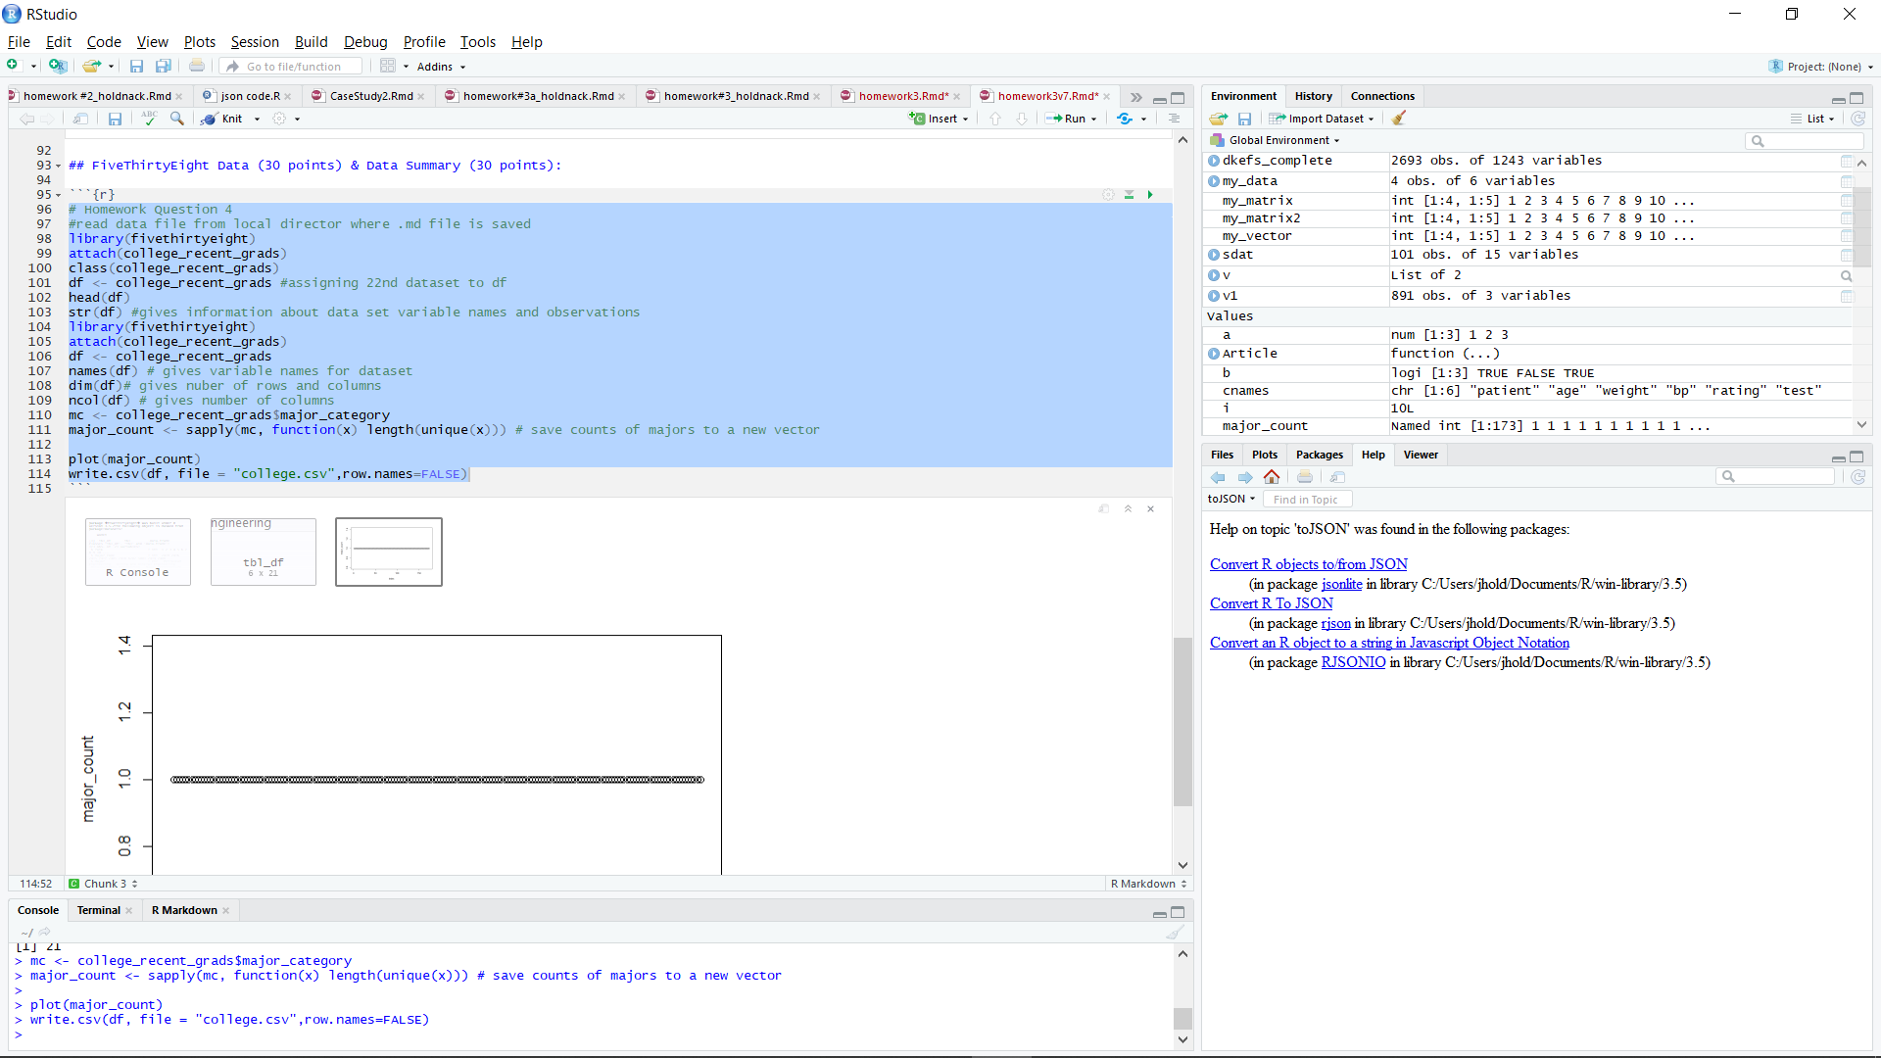

Section 3 runs and saves csv file to my director – not sure why sapply not recognizing unique values

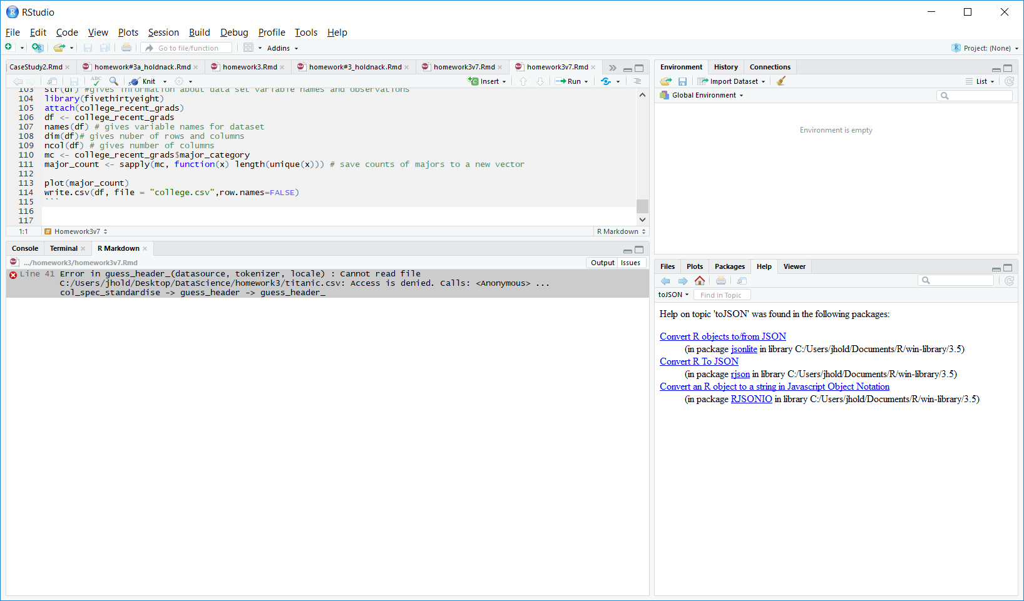

When I go to knit it keeps giving me a file access error no matter what I TRY. This is run as administrator with no restrictions on access to the files.



The file college.csv was correctly saved so the only issue I have is with the knit function.